**Basic Script Exercise Summary**

**Answers for Steps 5a and 5b:**

5a. Maximum response time topped out at approximately 1,700ms, while resources were being retrieved from purchase.php:

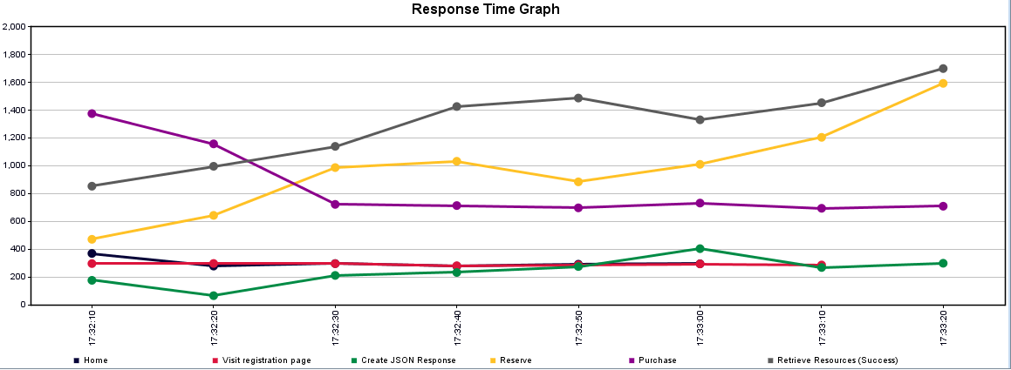

5b. The connected time for the second response (navigating to the registration page) was 135ms:

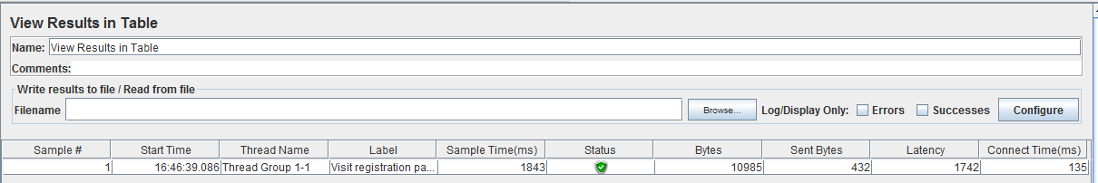

**Test results:**

The test ran successfully, which stepped through the following simulation:

1. Navigate to the blazedemo home page, verify “welcome” message, then wait 10 seconds.
2. Wait five seconds.
3. Visit the registration page, extract the CSRF token from it, then write the token to the log.
4. Beginning at this point, 50% of the users are split off to continue on to booking a flight. (The other 50% end at this step.)
5. Visit the flight reservation page.
6. Manually POST flight selection details to the purchase page (thus simulating a user entering the details on the reserve page, then clicking the “Choose this flight” JavaScript button), verifying success by watching for the text “reserved” on the next page.
7. If purchase succeeds, the resulting webpage (and its embedded resources) are saved to a file for manual review. If it fails, a similar file captures the failure results for manual review.
8. The dummy sampler creates a static response consisting of JSON text detailing name data, from which the last name of one specified individual is written to the log.

**What I would have enhanced:**

I included some items in the provided script that enhance behavior to better simulate a browser: I added an HTTP Cookie Manager, Cache Manager, and Authorization manager, then likewise added HTTP Header managers to the various HTTP Request samplers, since the recorder easily captured this information.